**Equine Challenge Supplements**

**559-905-7528**

**https://equinechallengesupplements.com**



|  |
| --- |
| Equine Challenge Essential Oils For Horses & equestrians |
|  |
|  |

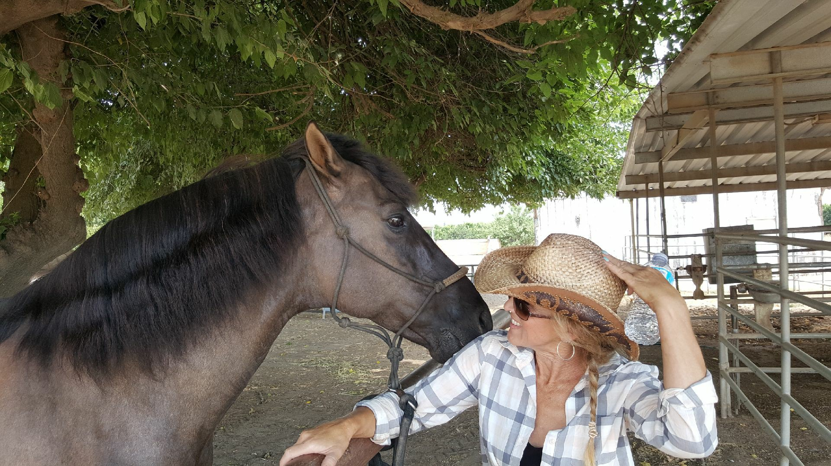

Welcome! We are pleased and excited to now be providing a complete line of Essential Oils to our line of health & wellness products being offered at Equine Challenge Supplements.

We are always seeking new ways to help horses to not just live, but to thrive. We have done extensive research into these Essential Oils, and given the results we have seen, we strongly believe in the quality and benefits for both horse and equestrian, the uses are endless!

we are often asked “my horse is doing so great on your supplements do you have anything I can take?” Now the answer is yes! Not only will these essential oils help your horse, your entire family can use and benefit from them!

|  |
| --- |
|  |

|  |
| --- |
| Essential oils…total wellness support |

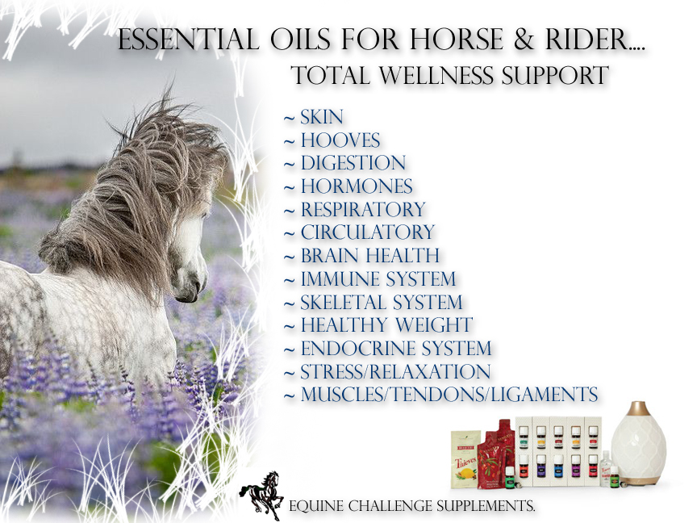

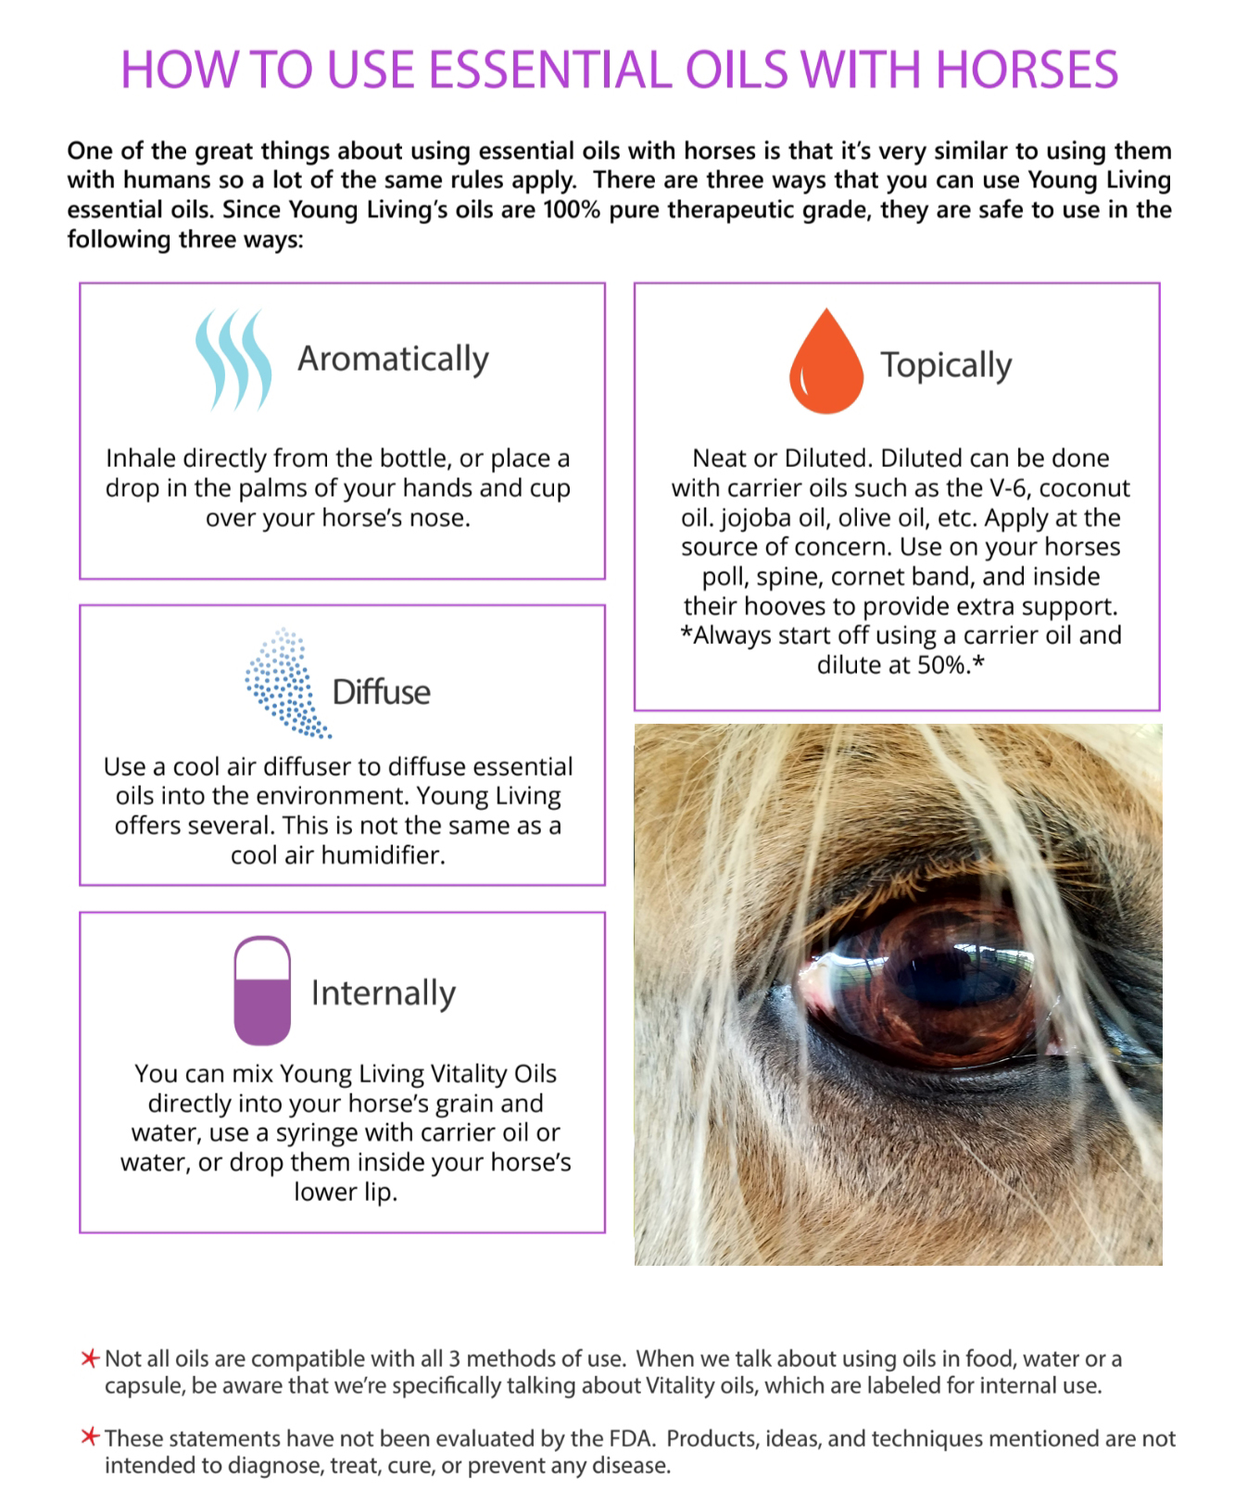

How To Use Essential Oils With Horses

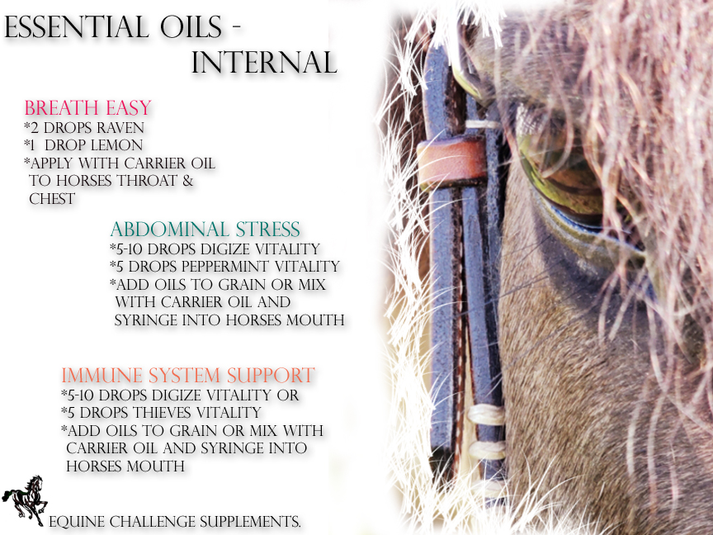

These recipes can apply to both horses and equestrians

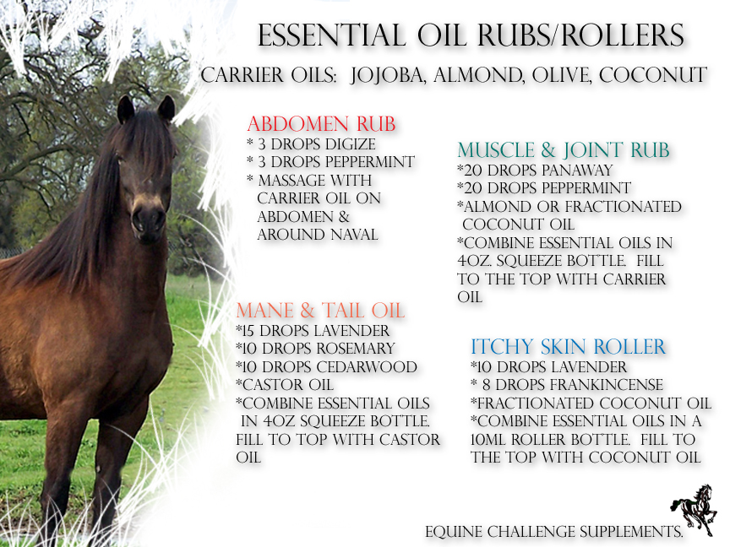

3 of These recipes can apply to both horses and equestrians

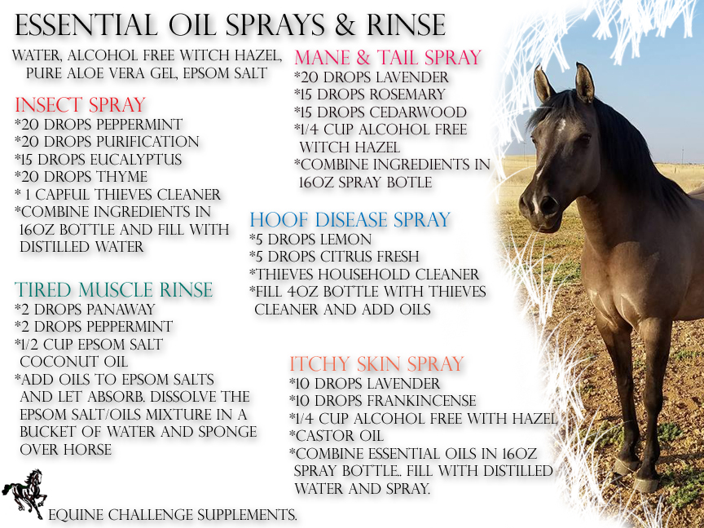

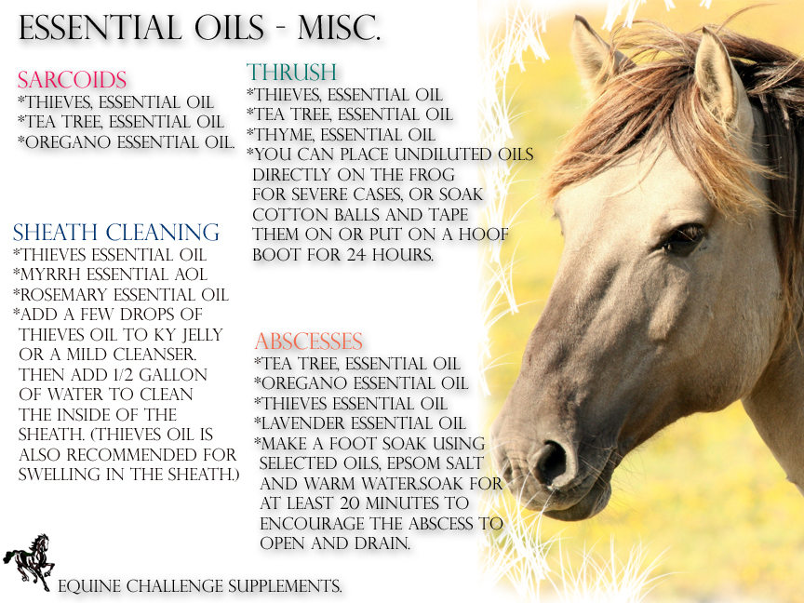

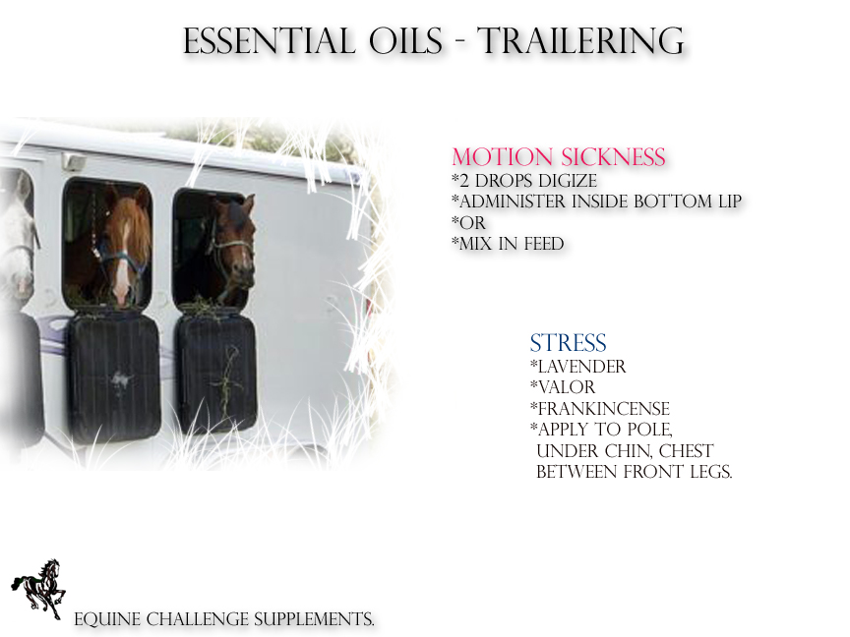

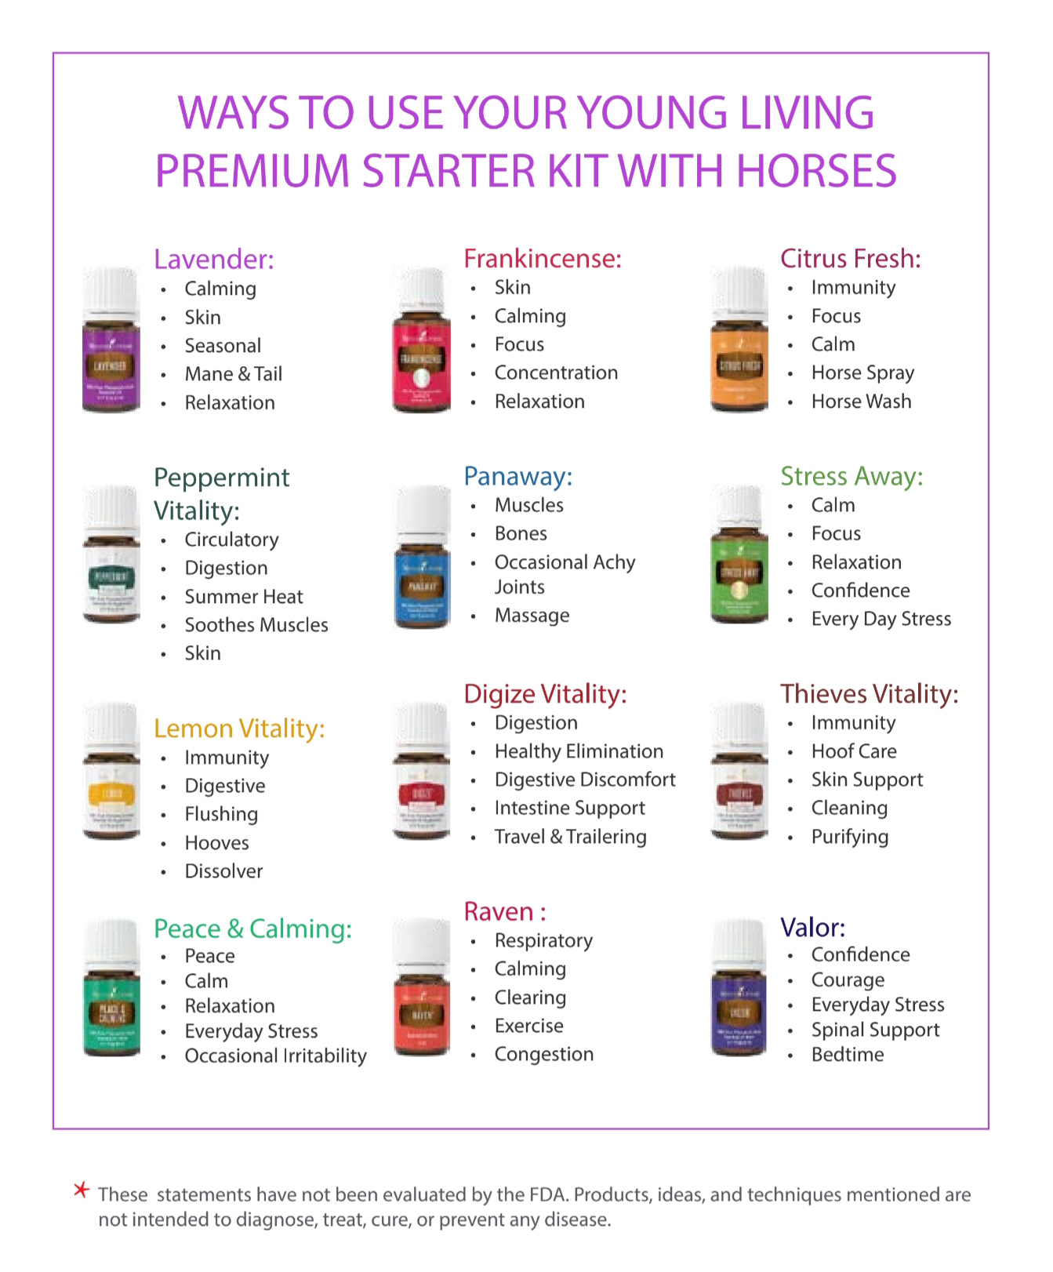

Suggestions for using essential oils with horses & Equestrians

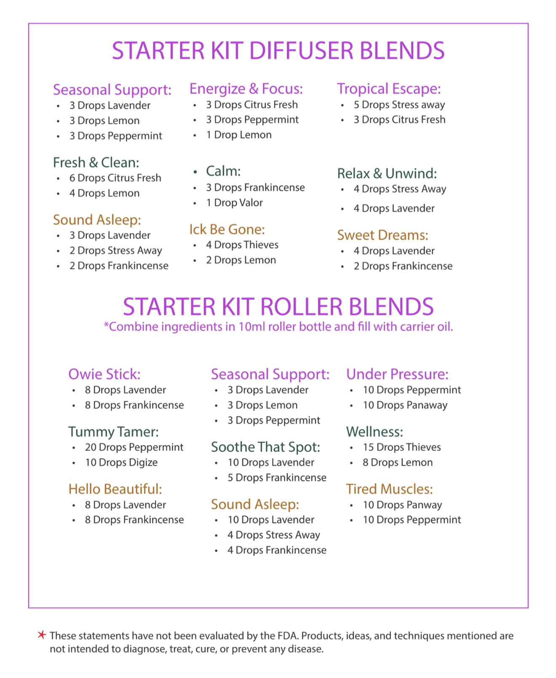

Starter Kit Roller Blends

Starter Kit Diffuser Blends

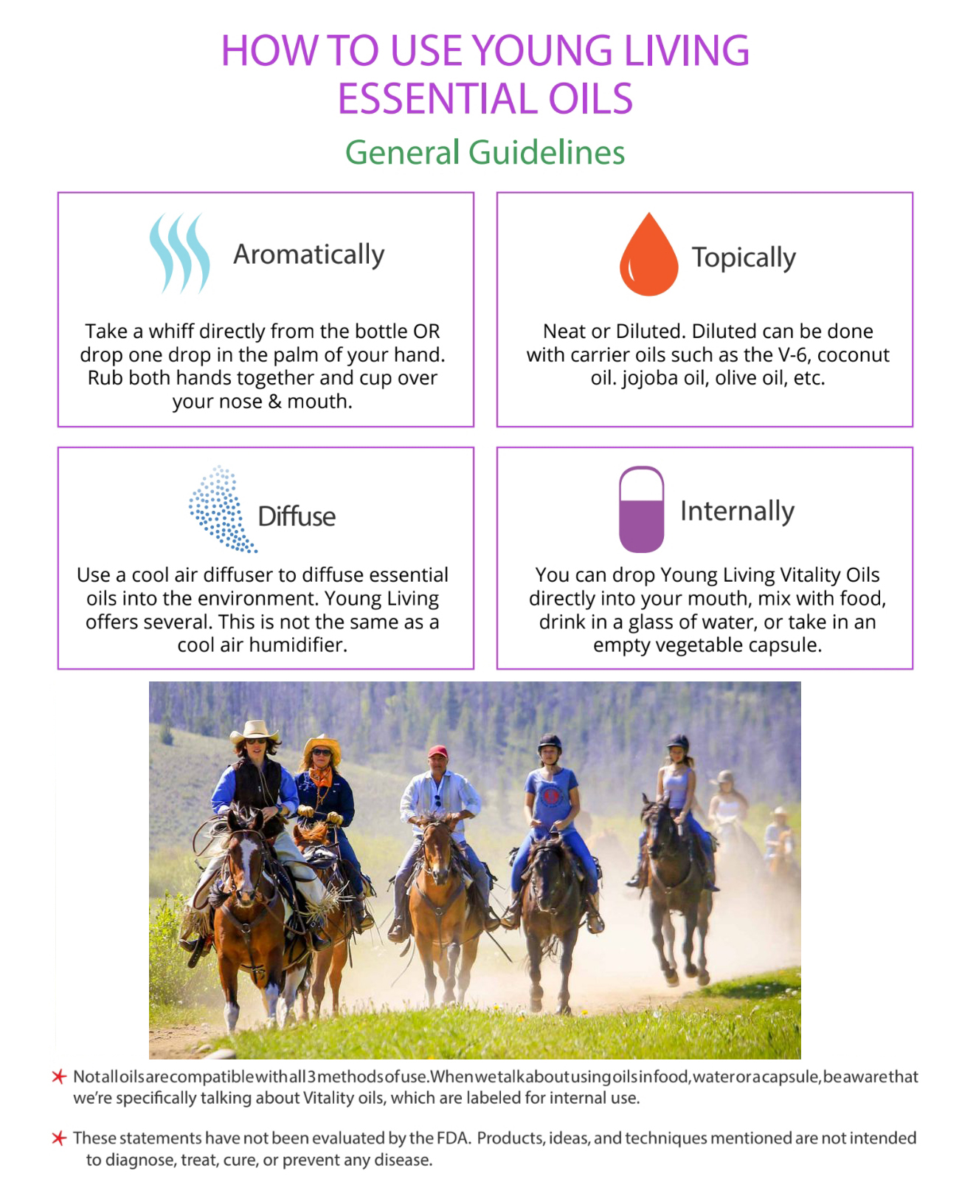

How to use essential oils for the family

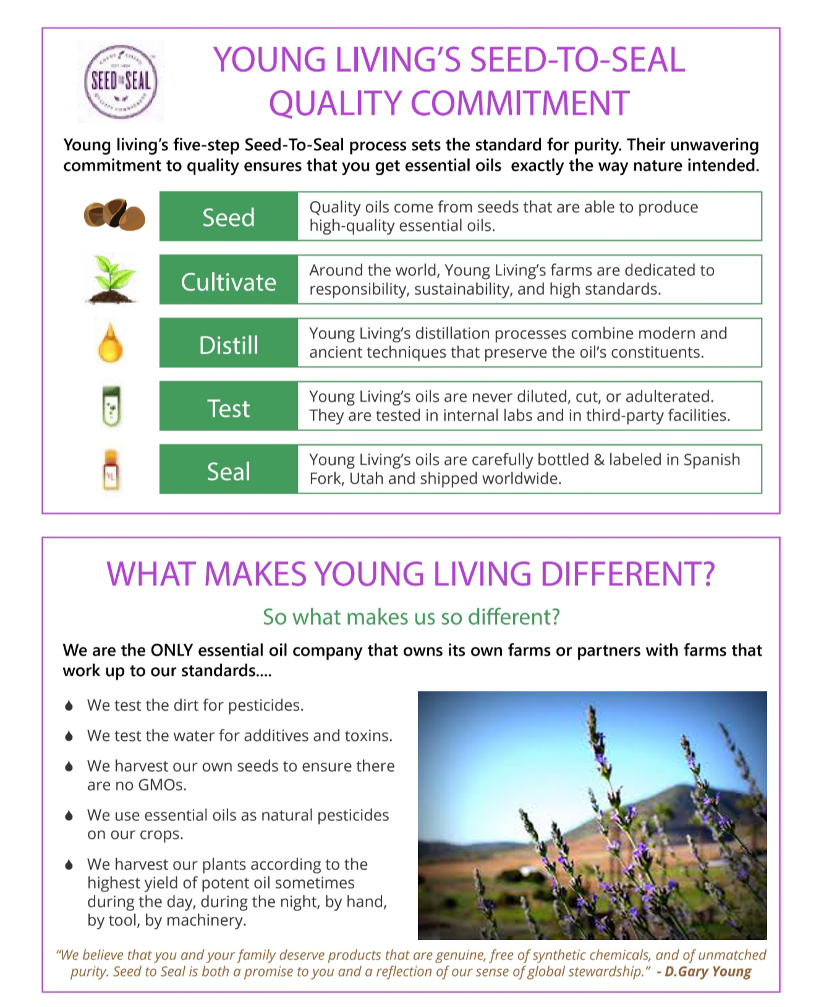

What makes young living essential oils so different?

Young Livings Seed To Seal Quality Commitment